Trade of Sheet Metalwork
Module 7: | Introduction to CNC Sheet Metal Manufacturing
Unit 7: | CNC Setting & Operation
 | Phase 2

Table of Contents
List of Figures 4
List of Tables 5
Document Release History 6
Module 7 – Introduction to CNC Sheet Metal Manufacturing 7
Unit 7 – CNC Setting & Operation 7
Learning Outcome: 7
Key Learning Points: 7
Training Resources: 7
Key Learning Points Code: 7
Turret Punch Press 8
Bending Sequence 8
Punching Sequence 8
Material Specification for Common Materials 9
Workpiece and Tool Setting 10
Setting Axis Datums 10
Information Contained in the Title Block of a Drawing 14
Turret NO1 14
Prepare Task Plan 14
Data Sheets Codes 15
G Codes 17
Planning Sheet 20
Programming Sheet 21
Punching Exercise Example 22
Planning Sheet 23
Self Assessment 24
Answers to Questions 1-2. Module 7.Unit 7 25
Index 26

List of Figures
Figure 1 - Material Specification for Common Materials 9
Figure 2 - Machine Datum and Workpiece Datum 10
Figure 3 - CNC Setting & Operation 1 11
Figure 4 - CNC Setting & Operation 2 11
Figure 5 - CNC Setting & Operation 3 12
Figure 6 - CNC Setting & Operation 4 12
Figure 7 - CNC Setting & Operation 5 13
Figure 8 - CNC Setting & Operation 6 13
Figure 9 - G Codes 16
Figure 10 - Planning Sheet 20
Figure 11 - Programming Sheet 21
Figure 12 - Punching Exercise Example 22
Figure 13 - Planning Sheet 2 23

List of Tables

Document Release History
Date | Version | Comments
23/01/07 | First draft
09/04/14 | 2.0 | SOLAS transfer

Module 7 – Introduction to CNC Sheet Metal Manufacturing

Unit 7 – CNC Setting & Operation
Duration – 20.5 Hours

Learning Outcome:
By the end of this unit each apprentice will be able to:
- Produce simple components on a CNC Punch Press having prepared a part program
- Produce simple components on a CNC Press Brake having prepared a part program

Key Learning Points:
Sk Rk | Correct selection and installation of tooling/die clearance. Position of workpiece relative to machine datum, start-up and referencing CNC machines.
Sk | Generation of part programs.
Rk | Data transfer.
H | Hazards associated with setting and operating CNC machines. Safety precautions associated with material removal from punching zone.
Rk | Know where emergency stop buttons are.

Training Resources:
- CNC Punch Press
- CNC Press Brake
- Prepared part programs

Key Learning Points Code:
M = Maths D= Drawing RK = Related Knowledge Sc = Science
P = Personal Skills Sk = Skill H = Hazards

Turret Punch Press
Turret press brake can have a large number of stations in the turret. A skilled operator will easily select the correct tooling for the job. While the machine may have a limited number of work stations the company may have extra tooling stored nearby.

Die clearance is an important aspect of tool selection.

The workpiece will be positioned using the datum points of the clamps and the locating pin. This gives us our X and Y axis. Start-up and referencing of machine will be demonstrated by the instructor.

Bending Sequence
The operator must work out accurately any bend allowances in the job. These calculations will influence the positions of holes/apertures punched and nibbled. The operator should also be sure the correct bend sequence is decided and used. With new programmes it is advisable to run a test piece.

Punching Sequence
- Single holes
- Line of holes
- Grids
- Slots of tool size
- Apertures, i.e. any shape bigger than the tool size
- Punch the perimeter

Material Specification for Common Materials

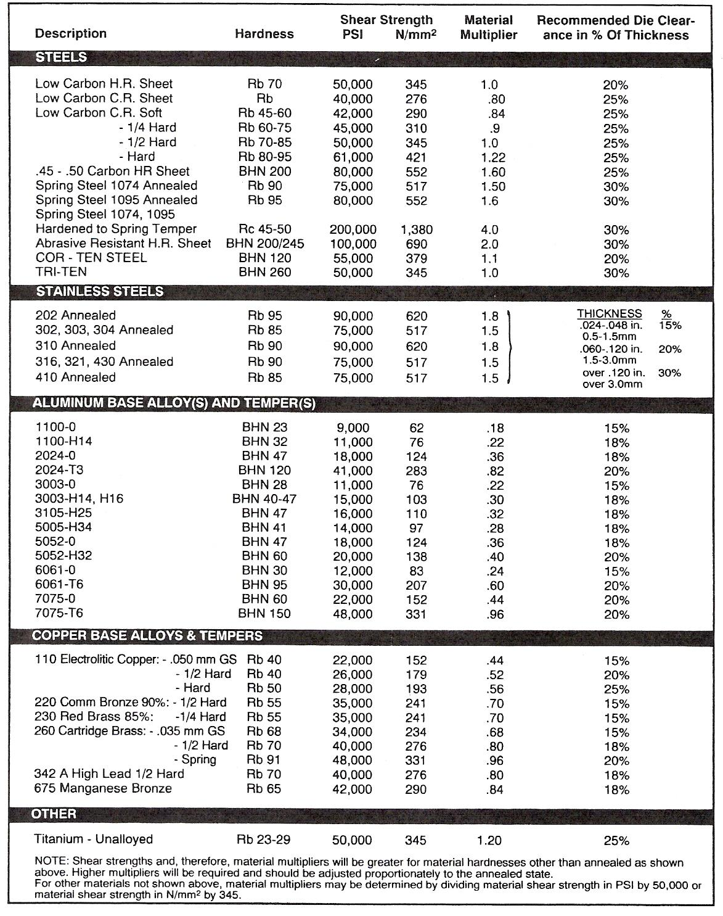
Figure 1 - Material Specification for Common Materials

Workpiece and Tool Setting
The machine datum is the point within the machine's range of movement from which the machine makes its programmed dimensional moves. It is an exact point on each axis that the machine can find even after power loss - this is the point the machine slides move to when you reference the machine. It is often called the zero datum or the machine reference point. Three axis machines usually have the Z axis datum position as the spindle fully retracted. When a workpiece is clamped, on the m/c table the workpiece datum and the machine datum will not normally coincide. In order to relate the two a floating zero facility is provided. This means that the operator can arbitrarily designate as zero any point on each axes within the range of slide displacement.

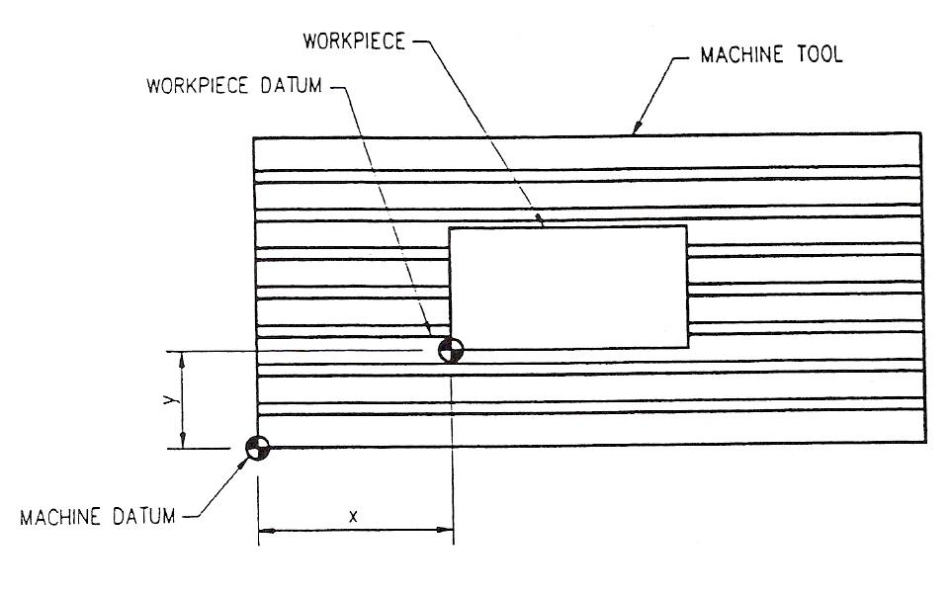
Figure 2 - Machine Datum and Workpiece Datum

Setting Axis Datums
On CNC machines employing fully floating datum facilities it is common to position the workpiece or workholding device on the machine table, for convenience. The tool, or setting probe, is then jogged manually to touch the component in each axis in turn. With the tool or setting probe in the correct setting position (component datum position), one of two actions may be taken. The choice will depend on the machine tool.

The first action involves setting the relevant axis register to zero, by entering at the console. A button marked 'axis zero' may also have to be depressed to confirm the action. Thereafter, the machine zero position is assumed to be that point. All subsequently programmed positional moves will be made with reference to this zero point.
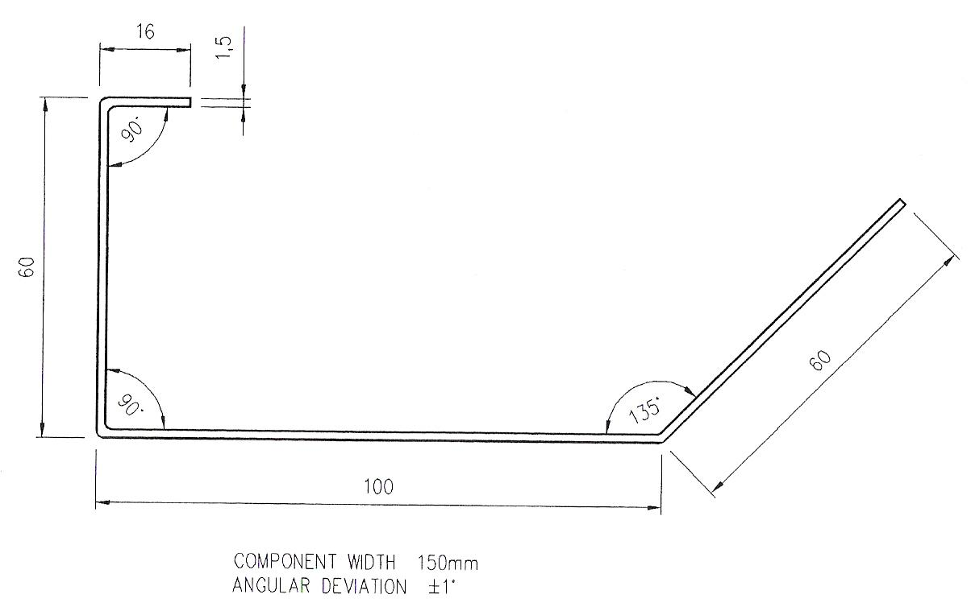
Figure 3 - CNC Setting & Operation 1

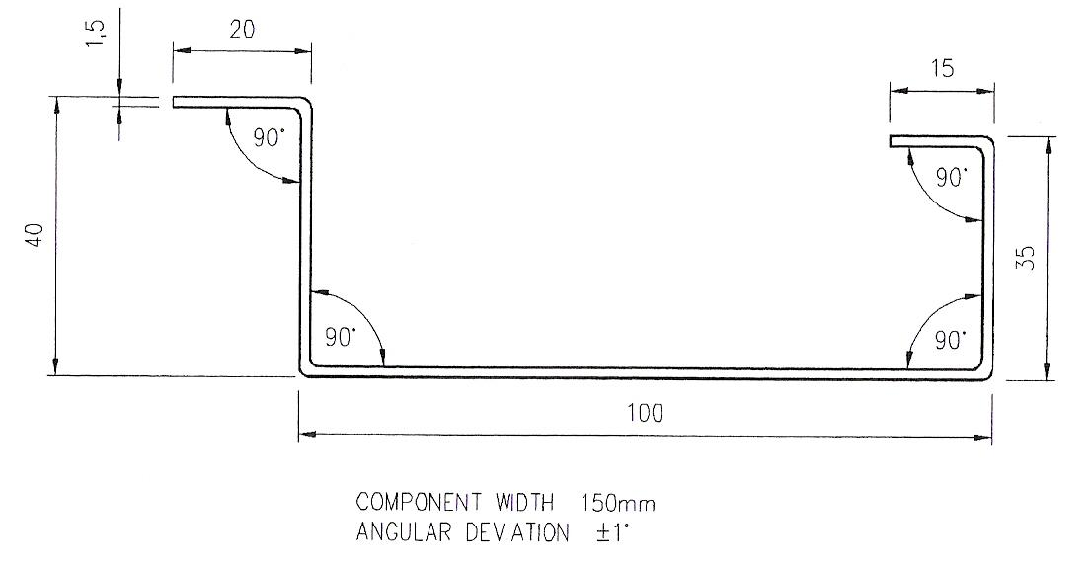
Figure 4 - CNC Setting & Operation 2
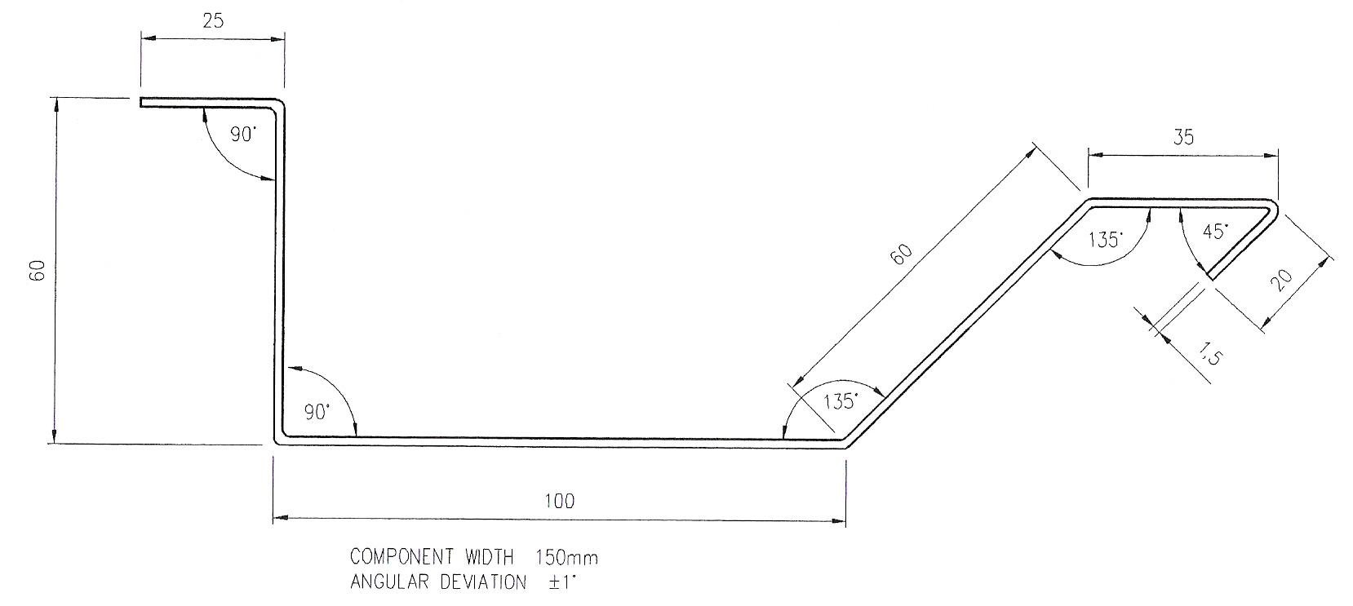
Figure 5 - CNC Setting & Operation 3

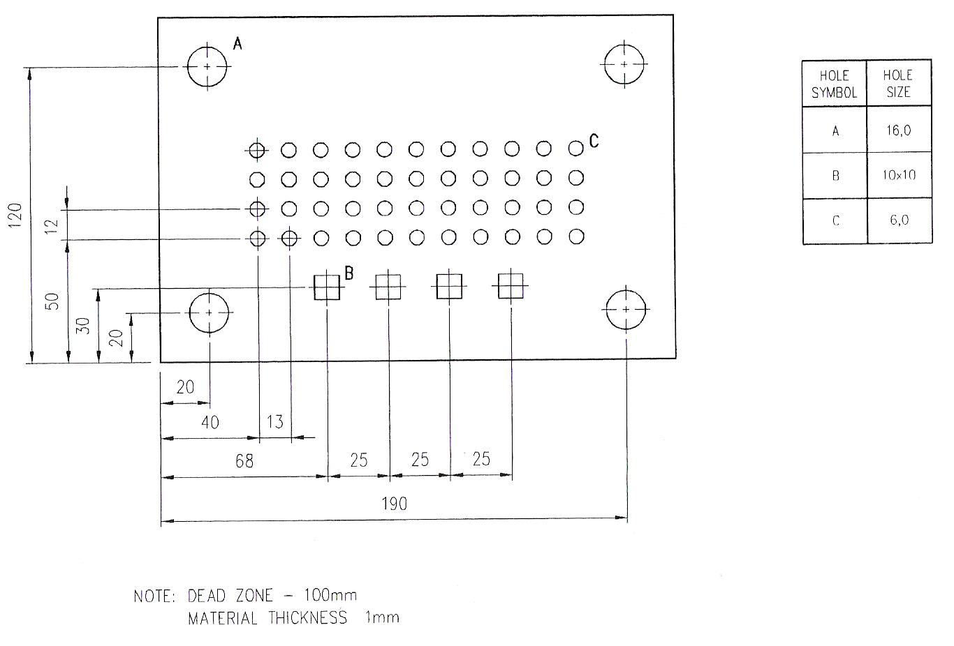
Figure 6 - CNC Setting & Operation 4
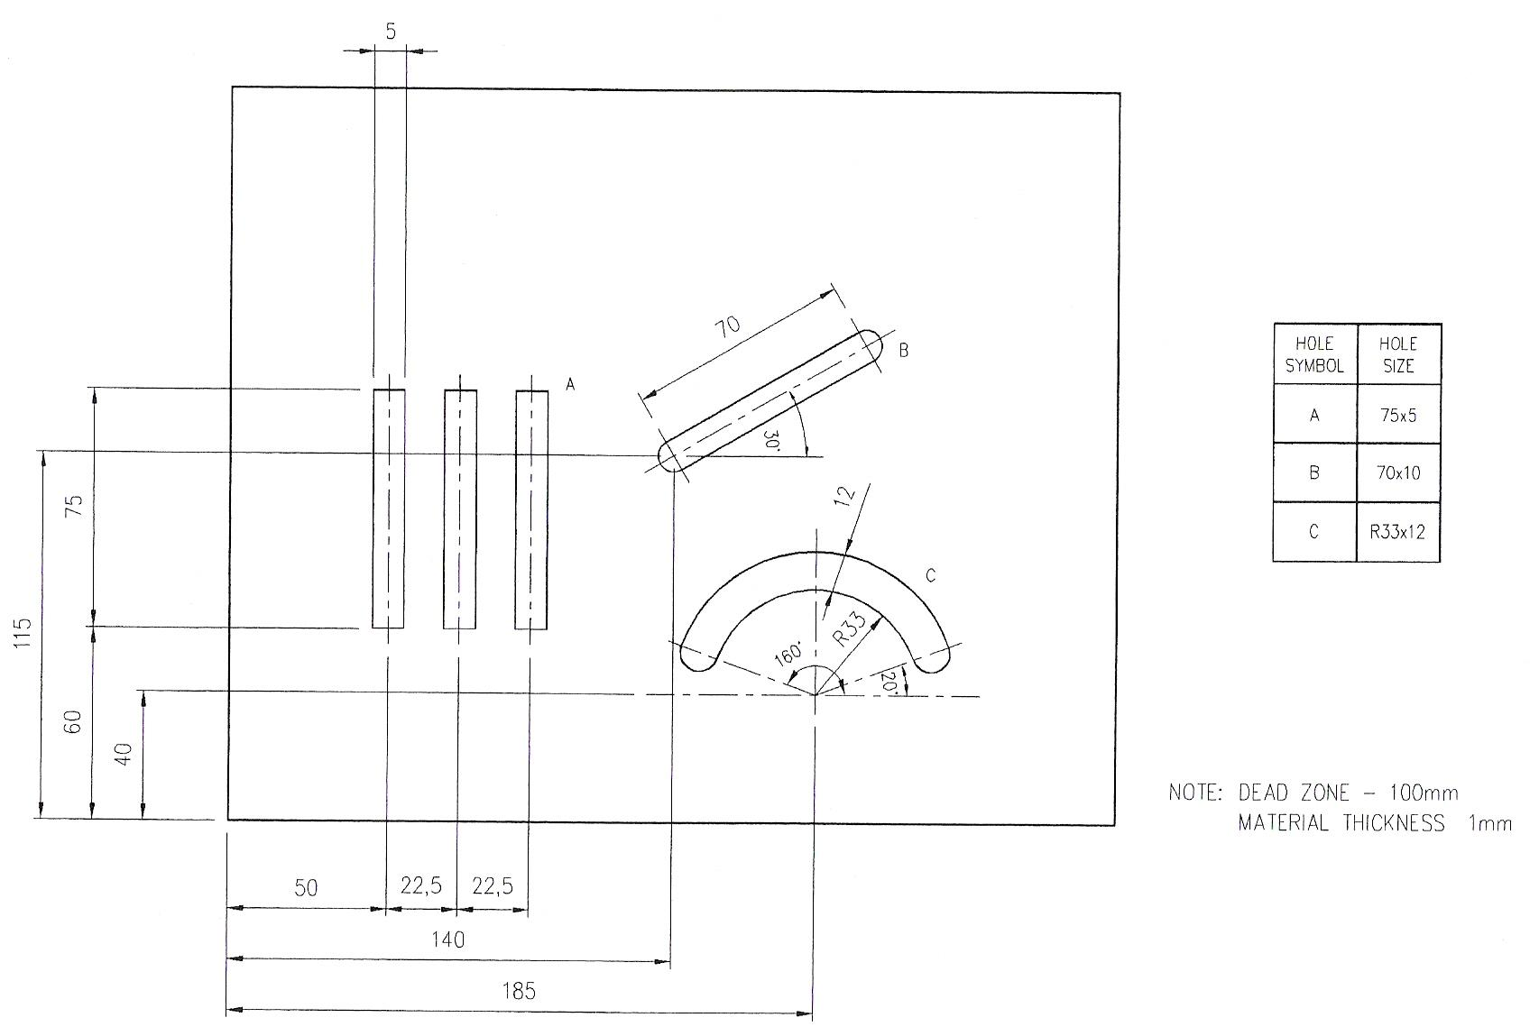
Figure 7 - CNC Setting & Operation 5

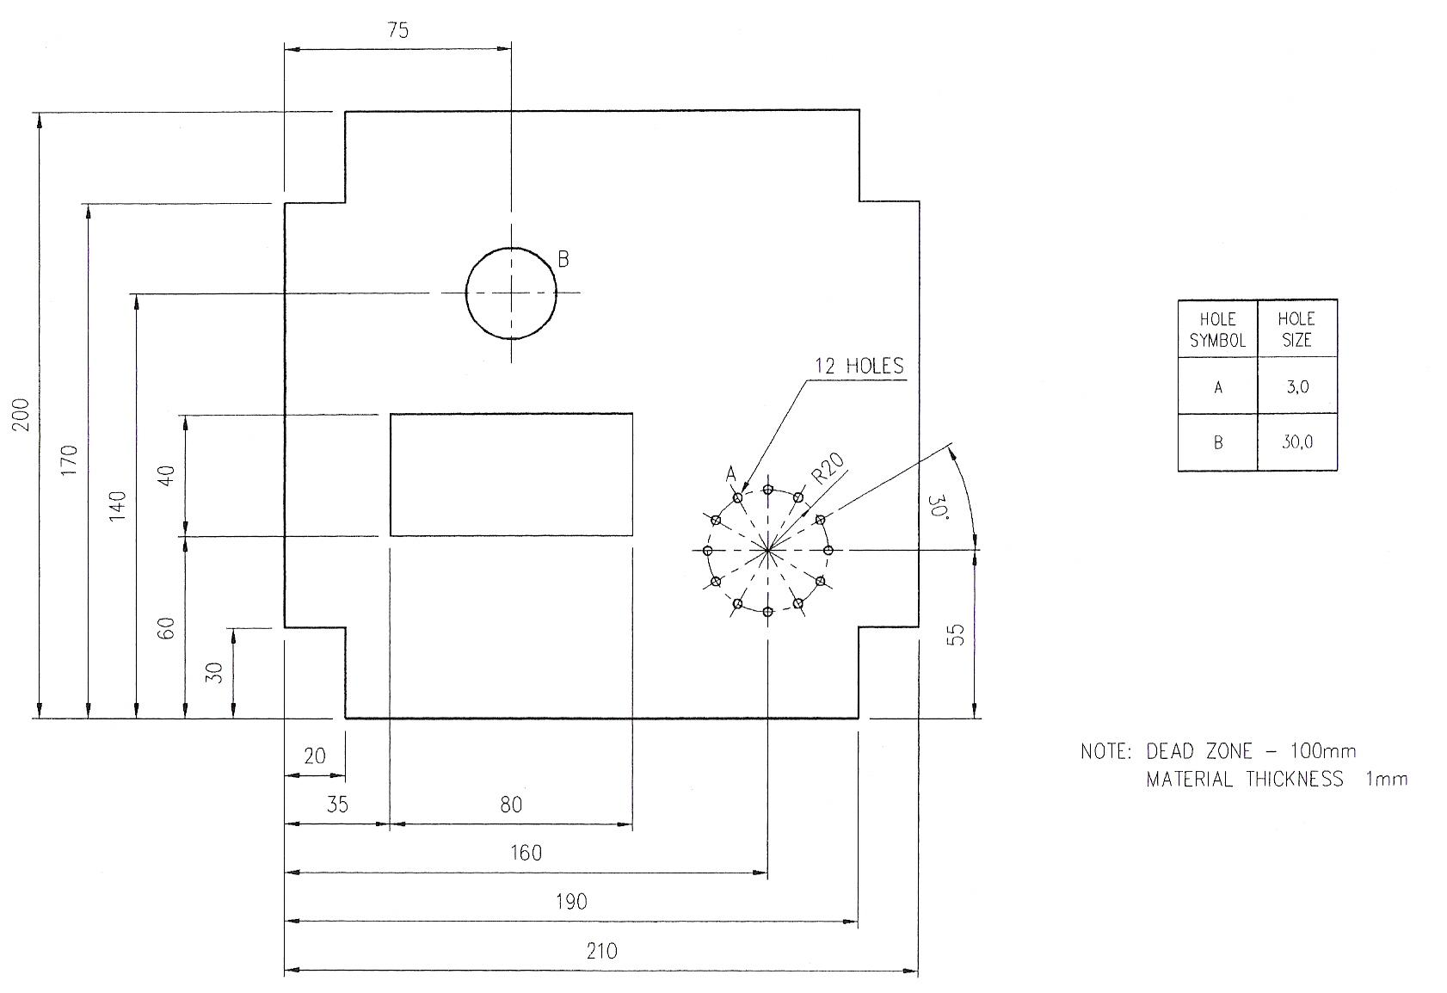
Figure 8 - CNC Setting & Operation 6

Information Contained in the Title Block of a Drawing

- Project title
- Date of original drawing
- Job no.
- Drawing no.
- Scale
- Name of Draughtsman
- Name of Architect
- Name of Engineer

Turret NO1
STATION 1 RECTANGLE X = 85 Y = 5 A = 0° LARGE STATION
STATION 2 ROUND D = 14
STATION 3 ROUND D = 12
STATION 4 RECTANGLE X = 15 Y = 15 A = 0°
STATION 5 RECTANGLE X = 9 Y = 9 A = 0°
STATION 6 RECTANGLE X = 85 Y = 5 A = 90° LARGE STATION
STATION 7 ROUND D = 3
STATION 8 RECTANGLE X = 25 Y = 5 A = 90°
STATION 9 RECTANGLE X = 25 Y = 5 A = 0°
STATION 10 ROUND D = 6

Prepare Task Plan
- Read the component drawing to identify material type and thickness
- Identify equipment needed (punches and dies)
- Develop out the coordinate drawing
- Identify the punches required
- Identify the G codes required
- Write the programme

Data Sheets Codes
For the purposes of this examination, select your program codes from the following list:

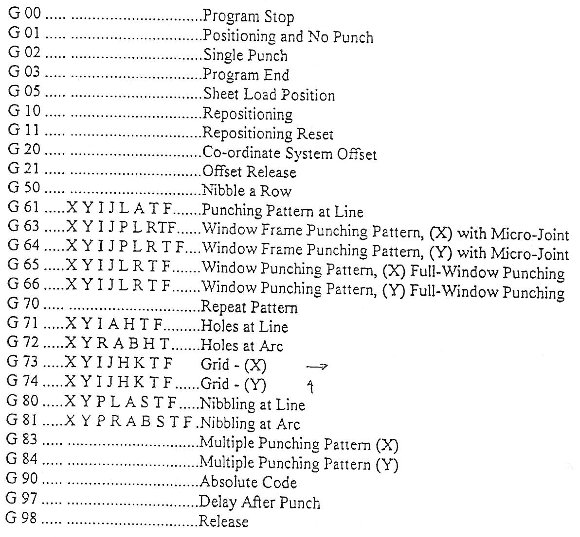

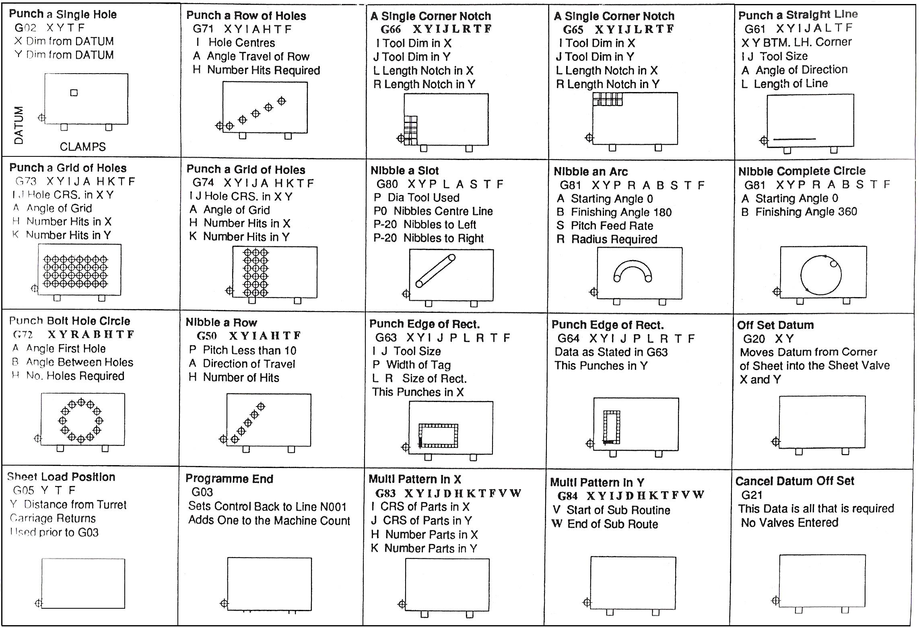
Figure 9 - G Codes

G Codes
The following 'G' Codes refer to the code required to enable the machine to function.
The 'X' and 'Y' refer to dimensions from the datum point to the centre of the tool being used, (unless stated otherwise).
'T' and 'F' refer to the TURRET STATION NUMBER (i.e. T2) and to the FEED RATE required (i.e. F20).
PUNCH A SINGLE HIT G02XYTF

PUNCH A ROW OF HOLES: G71XYIAHTF
I = Centres between holes
A = Angle of travel of row
(in increments of 0.01 degree)
H = Number of hits (holes) required

PUNCHING A LINE G61XYIJLATF
Please note X = The corner start position of the slot required
Please note Y= The corner start position of the slot required
I = Size of tool in the direction of travel
J = Width of tool
Please note 'J' has two variables
Using for example a 25 x 5 tool
J5 produces a slot to the left of direction of travel
J-5 produces a slot to the right
L = Length of Line
A = Angle of Direction

CIRCULAR PATTERN G72XYRABHTF
R = Radius
A = Starting angle
B = Incremental angle between holes
H = Number of hits required

GRID OF HOLES IN X G73XYIJAHKTF
I = Centres between holes in the X direction
J = Centres between holes in the Y direction
A = Angle of the Grid
H = Number of hits required in the X axis
K = Number of hits required in the Y axis

GRID OF HOLES IN Y G74XYIJAHKTF
Note G74 Uses the same parameters as G73 above.
NIBBLING A SLOT G80XYPLASTF
P = The diameter of tool being used for nibbling
Please note 'P' has three variables
P = 0 (will nibble a slot along the centre line)
P = 12 (using a 12 dia. punch, this will nibble to the left of centre)
P = -12 (using a 12 dia. punch, this will nibble to the right of centre)
L = Length of slot required
A = Angle at which the slot is generated
S = 1 to 10 (this corresponds to the pitch of each blow)
S10 is a pitch of approx. 6.0mm.
S1 therefore is equal to a pitch of approx. 0.6mm
S3 (= 6\10 x 3 = approx. 1.8mm pitch)

NIBBLING A CIRCLE G81XYPRABSTF
P = The diameter of tool being used for nibbling
Please note 'P' has three variables
P = 0 (will nibble a slot along the centre line)
P = 12 (using a 12 dia. punch, this will nibble to the left of centre, outside the circle)
P = -12 (using a 12 dia. Punch, this will nibble to the right of centre, inside the circle)
R = Radius Required
A = Starting Angle
B = Finishing Angle
S = 1 to 10 (this corresponds to the pitch of each blow)
S10 is a pitch of approx. 6.0mm.
S1 therefore is equal to a pitch of approx. 0.6mm
S3 (= 6\10 x 3 = approx. 1.8mm pitch)

PUNCHING AN APPERATURE G63XYIJPLRTF
IN X AXIS I = Tool dimension in X
J = Tool dimension in Y
P = Width of micro-joint
L = Length of aperture along the X axis
R = Width of aperture along the Y axis
Please note X = The comer start position of the aperture required
Please note Y = The comer start position of the aperture required
Using this code holds the scrap centre area in position with micro- tags.
Micro-tag = 20% - 25% thickness of metal

PUNCHING AN APPERTURE G64XYIJPLRTF
IN Y AXIS Note G64 uses the same parameters as G63 above.
WINDOW PUNCHING G65XYIJLRTF
PATTERN IN X AXIS I = Tool dimension in X
J = Tool dimension in Y
L = Length of aperture along the X axis
R = Width of aperture along the Y axis
Please note X = The corner start position of the aperture required
Please note Y = The corner start position of the aperture required
Using this code clears the area completely.

WINDOW PUNCHING G66XYIJLRTF
PATTERN IN Y AXIS Note G66 uses the same parameters as G65 above.

Planning Sheet

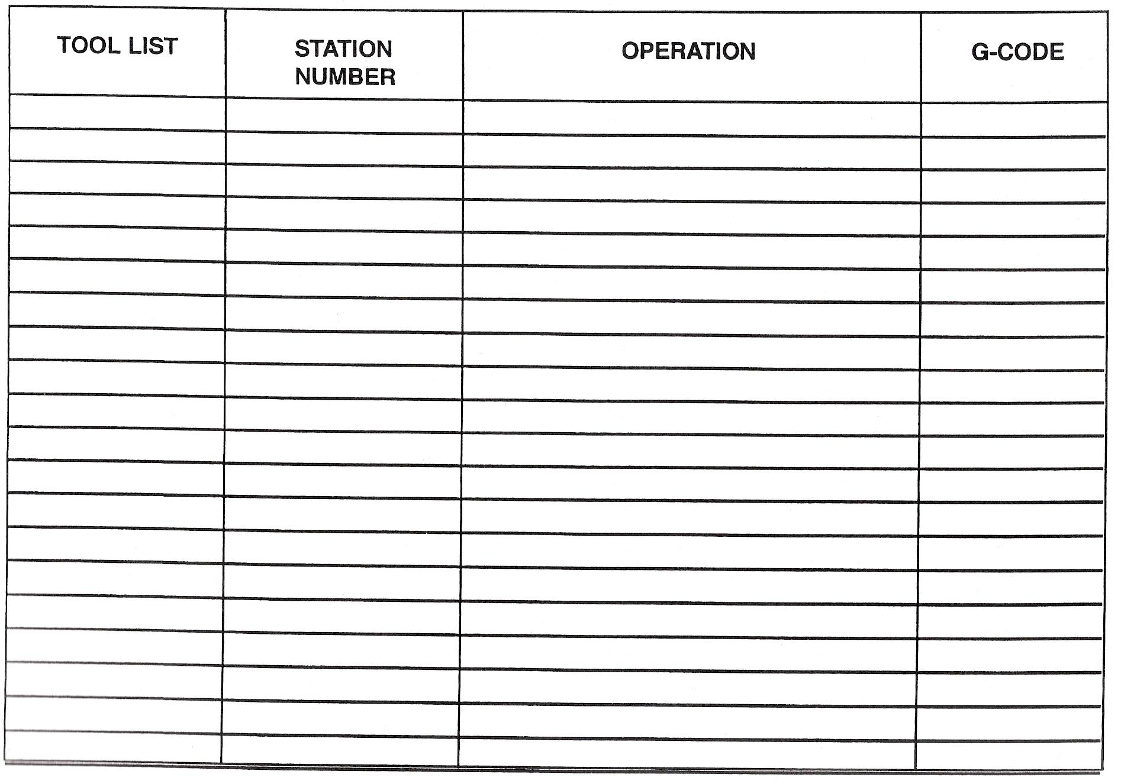
Figure 10 - Planning Sheet

Programming Sheet
Test: P1 NISIMBO MAP-500
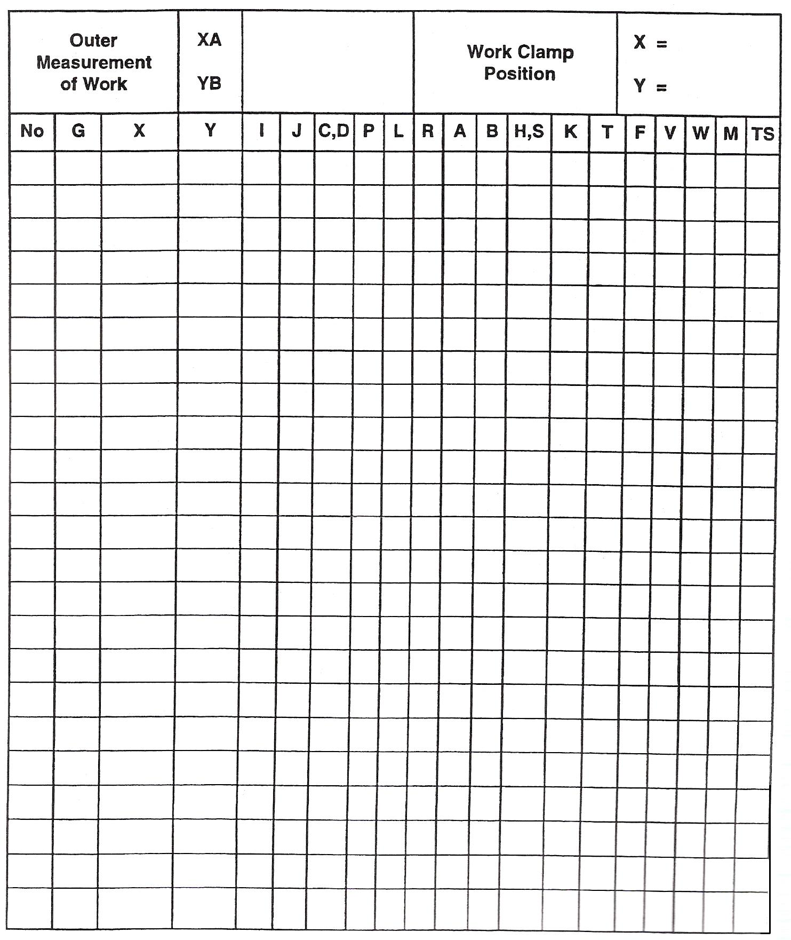
Figure 11 - Programming Sheet

Note: Can be applied to individual machine requirements.

Punching Exercise Example

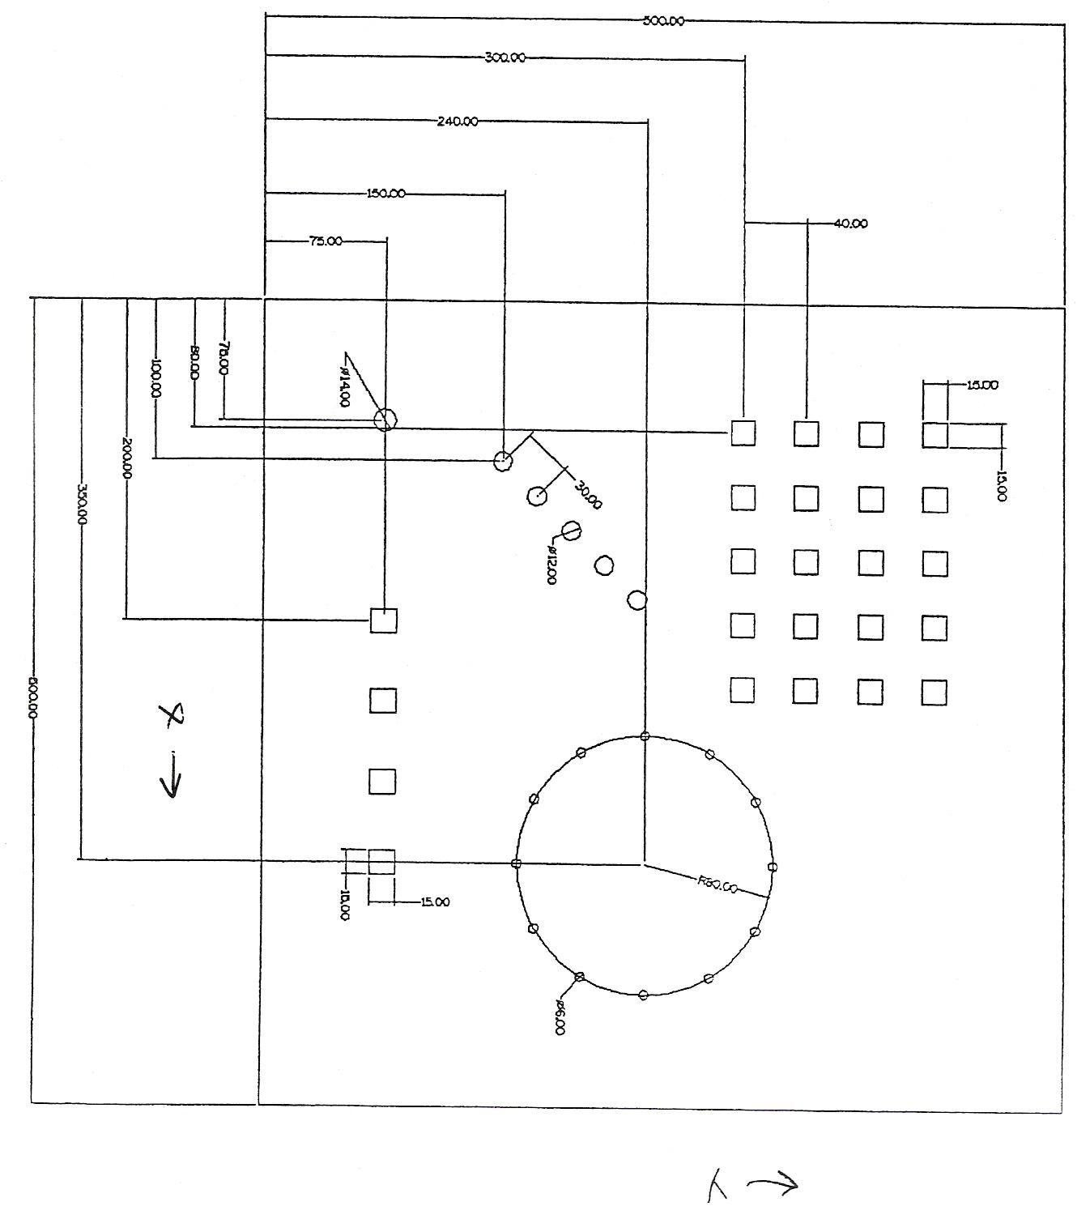
Figure 12 - Punching Exercise Example

Planning Sheet
Test: P1 NISHIMBO MAP-500
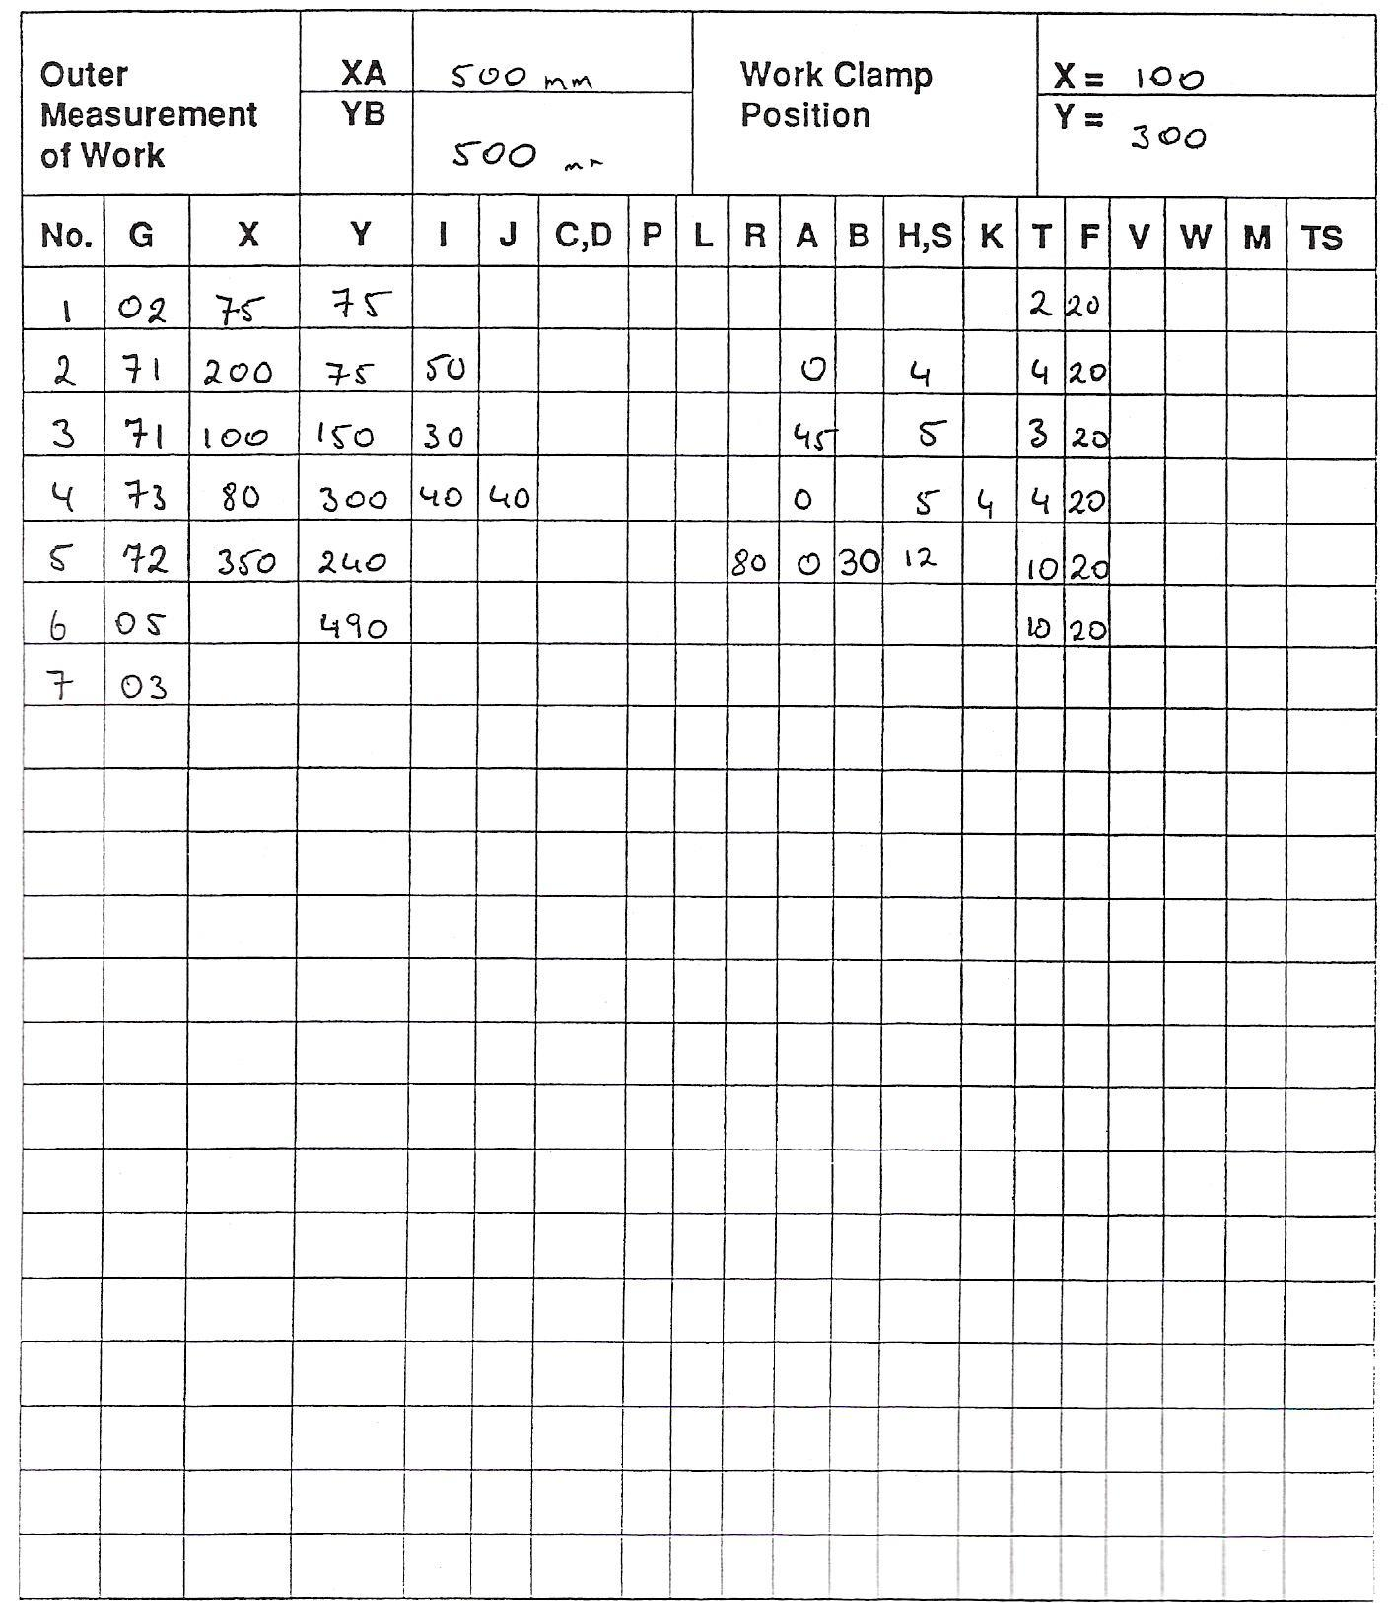
Figure 13 - Planning Sheet 2

Note: Can be applied to individual machine requirements.

Self Assessment

Questions on Background Notes – Module 7.Unit 7

1. List the Punching Sequence.

2. List the Task Plan.

Answers to Questions 1-2. Module 7.Unit 7
1.

Punching Sequence:

a. Single Holes
b. Line of Holes
c. Grids
d. Slots of Tool Size
e. Apertures
f. Punch the Perimeter

2.

Task Plan:

a. Read the component drawing to identify material type
and thickness.

b. Identify equipment needed.

c. Develop out the coordinate drawing.

d. Identify the punches needed.

e. Identify the G codes required.

f. Write the programme.

Index

B
Bending Sequence, 8
D
Data Sheets Codes, 15
G
G Codes, 17
I
Information Contained in the Title Block of a Drawing, 14
M
Material Specification for Common Materials, 9
P
Planning Sheet, 20, 23
Prepare Task Plan, 14
Programming Sheet, 21
Punching Exercise Example, 22
Punching Sequence, 8
S
Self Assessment, 24
T
Turret NO1, 14
Turret Punch Press, 8
W
Workpiece and Tool Setting, 10
Setting Axis Datums, 10

